1. Introduction
1.1 PROJECT OVERVIEW
Normally users are not aware about all the treatment or symptoms regarding the particular disease. In this case they want to go to a hospital and consult a doctor. Most of the cases people consult MBBS doctor and sometimes he may not be the right doctor for us. So it is time consuming and sometimes we need to consult with other doctor. Such a problem can be solved by using “Smart health enquiry” by giving proper guidance regarding healthy living.
The smart health enquiry is an android application that helps users to submit their problem about health. The users can ask any questions or query related to that disease without physically available to the hospitals. Query is sent to this app and gets related answer and display answer on android app. It also suggests hospitals and doctors so people can easily consult the doctors. This app also suggests some prevention methods, patients care details, and also food that permitted to a patient etc.

1.2 SCOPE OF THE PROJECT
The proposed system is an app which is giving awareness about the symptoms and treatments. Through this app user can query about disease and get answer through it. It is very helpful in the medical field and as it giving awareness about symptoms, treatments, medicines, prevention, patients care etc it is helpful for the public also. They can get all the above details without physically available to the hospitals. Nowadays the disease rates are increasing this app get a wider scope.

2. System Analysis
System analysis is the process of collecting and interpreting facts, understanding problems and using the information to suggest improvements on the system. This will help to understand the existing system and determine how computers make its operation more effective. The aim of this analysis is to collect the detailed information on the system and the feasibility study of the proposed system. This analysis focuses on the flow of the system module by module and the efficiency of each. To design the proposed system we need the exact processing logic as well as the extended features of the existing system such as reliability, consistency, storage capacity etc. This report will discuss the advantages and drawbacks/ disadvantages of the existing system and the modifications and enhancements can be done. This analysis will concentrate on the information gathering for the efficient, user friendly and reliable system, which will carry forward the features of the existing system.
2.1 REQUIREMENT ANALYSIS
Requirements analysis results in the specification of software’s operational characteristics, indicates software’s interface with other system elements, and establishes constraints that software must meet. Requirements analysis allows you to elaborate on basic requirements established during the inception, elicitation, and negotiation tasks that are part of Requirements engineering.

REQUIREMENT GATHERING

The requirement gathering can be done in following ways

- Questionnaire
- Interview
- Site Visit
- Website visit
For this project I used interview method and website visit.
I interviewed some doctors and patients for this project.
The Interview questions are
Interview with Users
- Do you aware of all symptoms and treatment?
- What do you normally do when you are sick?
- If you are doing self treatment first, what is the reason for that?
- Are you aware of all the hospitals and doctors?
- How do you prefer a doctor for consulting?
- Do you prefer government hospitals or private hospital for treatment?
- How can you get the information about prevention method of a disease?
- Do you aware of the patients care details?
- Do you face any problem when consulting with doctors?
- From where do you get the information about the hospitals and doctors?
Interview with doctors
- Do you face any difficulty when consulting a patient?
- Some patients are doing self treatment. So what is the reason for that?
- How the patients get information about prevention method about a particular disease?
- Do you think that patients are aware about the patients care details?
- Do you think that patients didn’t get proper care from the caretaker as he is not aware of the care details?
Apps I visited
1. Gyant
It is a health chatbot that asks patients to understand their symptoms and sends data to a particular doctor who provides and prescribes medicine in real time
Demerits :
- Not providing any prevention methods or patients care details.
- The information’s are available only in Spanish or germen
2. Cancer chatbot
This app only providing the prevention methods and patients care details
Demerit:
- Not suggesting any doctor or hospitals.
- Not analyzing symptoms.
- Not suggesting age based medical dosage details.
- Not predicting disease.
3. Your.md
This app analyzing the symptoms and predict the disease
Demerits
- Not suggesting any doctor or hospitals.
- Not analyzing symptoms.
- Not suggesting age based medical dosage details.
4. Infermedia
This app analyzing the symptoms and predict the disease
Demerits
- Not suggesting any doctor or hospitals.
- Not analyzing symptoms.
- Not suggesting age based medical dosage details.
2.2 EXISTING SYSTEM
In existing system, if the patients having any symptoms or disease they want to go to a hospital and consult a doctor. This is the usual procedure for all people who are having different kinds of disease. Sometimes the people are not ready to consult a doctor if they having symptoms too because they are busy with their work. Sometimes people are interested in self treatment. Most of the cases people consult MBBS doctor and sometimes he may not be the right doctor for us. So it is time consuming and sometimes we need to consult with other doctor.
In other cases doctors are also may face difficulty when the patients are right patients for them. So consulting that type of patients are time consuming for them.
2.2.1 Problem with Existing System
The main drawbacks of existing system is given below
- People are not always ready with consulting a doctor.
- People are not aware of symptoms and treatment
- Sometimes the consulting doctor may not be the right doctor for patient
- Time consuming to consult with right doctor.
- People are not aware of all hospitals and doctors.
2.2 PROPOSED SYSTEM
The smart health enquiry is an android application that helps users to submit their problem about health. Users report the symptoms of their illness to the app, which checks them against a database of diseases using speech recognition, and then offers an appropriate course of action. As the user wishes, it can use text or speech to communicate. It also provides resources for caregivers to ease the burden of caring and making their lives easier. It also suggests hospitals and doctors so people can easily consult the doctors. This app also suggests some prevention methods which help the people in a good way. The admin is maintaining a site and through this they can add all the necessary details. The android application is available for the users. It also suggest age based medicine dosage details.
2.2.1 Advantage of Proposed System
Proposed system overcomes all the disadvantages of existing system. The proposed system will easily handle all the works done by the existing system. The main merits of the proposed system is given below

- Get the details about the disease without physically available to the hospitals.
- Get information about all hospitals and doctors in Kerala.
- Get information for caregivers to ease the burden of caring.
2.4 FEASIBILITY STUDY
Feasibility study is made to see if the project on completion will serve the purpose of the organization for the amount of work, effort and the time that spent on it. Feasibility study lets the developer foresee the future of the project and the usefulness.
Feasibility study is a test of system proposed regarding its workability, impact on the organization, ability to meet the needs and effective use of resources. Thus when a new project is proposed, it normally goes through a feasibility study before it’s approved for development.
The document provide the feasibility of the project that is being designed and lists various areas that were considered very carefully during the feasibility study of this project such as technical, economical and behavioral feasibilities.
The proposed system is theoretically investigated to check the feasibility and found that they are more reliable and reliable in the cases given below. There are three aspects in the feasibility study portion of the preliminary investigation.
- Economical Feasibility
- Technical Feasibility
- Behavioral Feasibility
- Legal Feasibility
The proposed system must be evaluated from a technical point of view first, and if technical feasible their impact on the organization must be assessed. If compatible, the operational system can be devised. Then they must be tested for economic feasibility.

2.4.1. Economic Feasibility
The developing system must be justified by cost and benefit. One of the factors which affect the development of a new system is the cost it would require. For implementing this app we need some resources such as modem, printer and some paper. These things are available with the health department itself .For maintaining the system and server we need to appoint a technical staff. It is expensive. But this app is very helpful to the public. And the benefits will be more. So the system is economically feasible.

2.4.2. Technical Feasibility
Through the technology may become obsolete after some period of time, due to the fact that newer version of some software supports older versions, the system may still be used. So there are only minimal constraints involved with this project. The system can be used by anyone without knowing the android framework. Those who have simple browsing experience, and those who are using the smart phone, they can easily use this app. It does not have any operational barriers. People don’t want to know the framework used by this system. By seeing the interface itself, the user can easily identify the functions. So the system is technically feasible.

2.4.3. Behavioral Feasibility
. The smart Health Enquiry is designed in user friendly manner and we need not to provide any special training for the persons using this software. Those who have simple browsing experience, they can easily use this app. The public are willing to accept the app as it easy to perform task. Hence it is behaviorally feasible.
2.4.3. Legal Feasibility The system cannot create any violation of rules and regulation of government. It is not making any security issues to outside world. So the system is legally feasible.
2.5 SYSTEM REQUIREMENT SPECIFICATION

System requirements are expressed in a software requirement document. The Software requirement specification (SRS) is the official statement of what is required of the system developers. This requirement document includes the requirements definition and the requirement specification. The software requirement document is not a design document. It should set out what the system should do without specifying how it should be done. The requirement set out in this document is complete and consistent. The software specification document satisfies the following:-

- It specifies the external system behaviors.

- It specifies constraints on the implementation.

- It is easy to change.

- It serves as reference tool for system maintainers.

- It record forethought about the life cycle of the system.

- It characterizes acceptable response to undesired events.

2.5.1 IDENTIFICATION OF ACTORS
An actor is someone or something that interacts with the system. An actor is he /she who use the system. An actor exchanges information with the system. Asking certain questions as detailed below can identify the actors of the system.

1 | Who will use the main functionality of the system? | Administrator, User
2 | Who will lead support from the system and do their daily tasks? | User
3 | Who will maintain and administrate the system? | Administrator
4 | With which other systems, does this system need to interact? | Database
5 | Who was interest in the result produced by the system? | Administrator, User

The answers to these questions bring out the actors of the system us.
- Administrator
- User
2.5.2 IDENTIFICATION OF USE CASES
A use cases represents the functionality of an actor. It is defined as a set of actions performed by a system, which yields an observable result. An ellipse containing its name inside the ellipse or below it represents it. It is placed inside the system boundary and connected to an actor with an association. This shows how the use cases and the actor interact.

To find out the use cases, ask the following questions to each of the actors.

- Which functions does the actor require from the system? What does the actor need to do?
- Does the actor need to read, create, destroy, modify or store some kind of information in the system?
- Does the actor has to be notified about events in the system, or does the actor need to notify the system about something? What do those the events represent in terms of functionality?
- Could the actor’s daily work be simplified or made more efficient by adding new functions to the system (typically functions which are currently not automated in the system)

Use Cases for the actor Administrator
1 | Which functions does the Administrator require from the system? What does the Admin need to do? | Administrator requires the following functionalities from the system such as add medical details, medicine details, add hospitals, add doctors, add prevention methods, add reason for disease and patients care details, add age based medical dosage details.
2 | Does the Administrator need to read, create, destroy, modify or store some kind of information in the system? | Yes, the administrator may login to the system as add medical details, medicine details, add hospitals, add doctors, add prevention methods, add reason for disease and patients care details, add age based medical dosage details.
3 | Does the Administrator have to be notified about events in the system, or does the actor need to notify the system about something? What do those the events represent in terms of functionality? | Yes, the Administrator has to be notified events represent all the functionality.
4 | Could the Administrator’s daily work be simplified or made more efficient by adding new functions to the system? | Yes, the system can reduce his/her daily work.

The above queries give the following use cases for the actor Administrator
- Login
- Add/Remove medical details
- Add/Remove medicine details
- Add/Remove diseases
- Search
- Add hospitals
- Add doctors
- Add prevention methods
- Add patients care details
- Add reason for diseases
- Add age based medical dosage details

Use Cases for the actor User
1 | Which functions does the user require from the system? What does the user need to do? | User require the following functionalities from the system such as search diseases, ask questions , search reasons and care
2 | Does the user need to read, create, destroy, modify or store some kind of information in the system? | Yes, the user may login to the system for ask questions and view hospital details and view doctors details, view the reason for the disease and view patients care
3 | Does the user have to be notified about events in the system, or does the actor need to notify the system about something? What do those the events represent in terms of functionality? | Yes, the user has to be notified events represent all the functionality
4 | Could the user’s daily work be simplified or made more efficient by adding new functions to the system? | Yes, the system can reduce his/her daily work.

The above queries give the following use cases for the actor user
- Login
- Ask questions
- Search diseases
- View hospital details
- View doctors details
- View medicine details
- View age based medical dosage details
- View patients care details
- View reasons
- View prevention method

Use Case Diagram - Admin

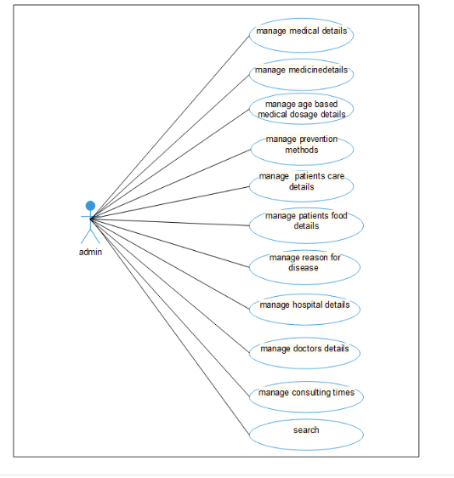

Usecase Diagarm -User

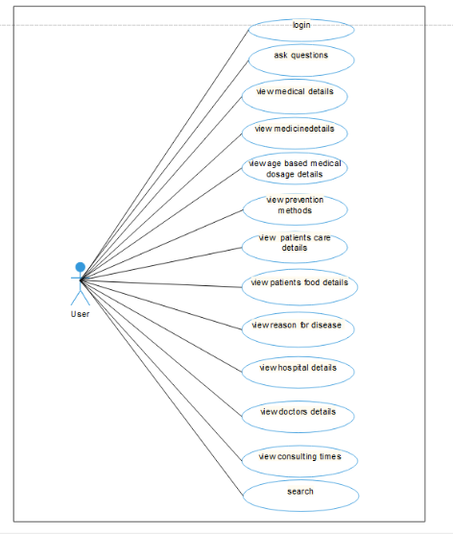

2.6.2 Activity Diagram
Activity diagram is an important diagram in UML to describe dynamic aspects of the system. Activity diagram is basically a flow chart to represent flow from one activity to another activity. The activity can be described as an operation of the system. So the control flow is drawn from one operation to another. This flow can be sequential, branched or concurrent. Activity diagrams deals with all type of flow control by different element like fork, join etc.
The basic purposes of activity diagrams are similar to other diagrams. It captures the dynamic behavior of the system. Other diagrams are used to show the message flow from one activity to another.

So the purpose can be described as:
- Draw the activity flow of a system.
- Describe the sequence from one activity to another.
- Describe the parallel, branched and concurrent flow of the system.

2.7.2.1 Activity Diagram-Administrator

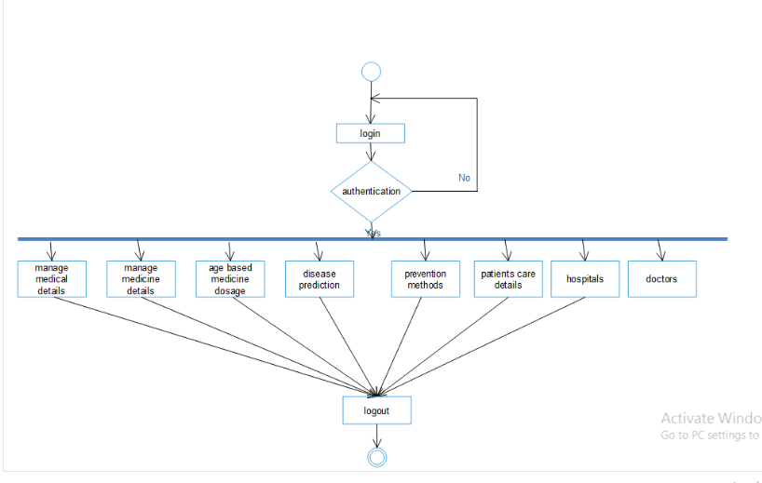

Activity Diagram-User

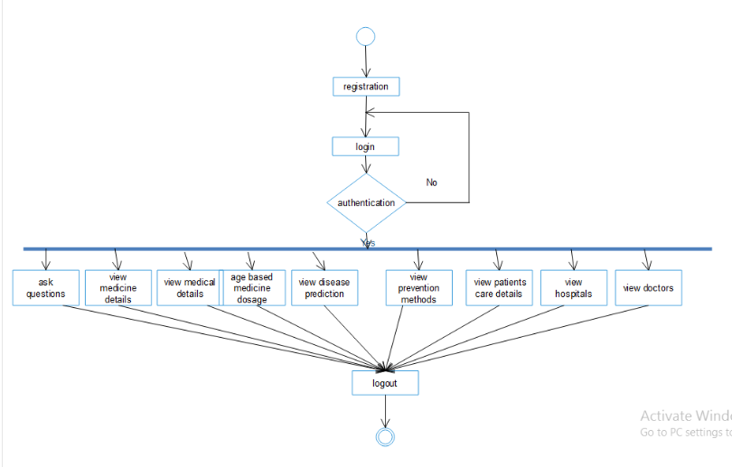

2.7.3 Sequence Diagram
Sequence diagram describes the behavior of the system by viewing the interaction between the system and its environment. A sequence diagram has two dimensions. Vertical dimension represent the time, horizontal dimension represent different objects. The vertical line is called life line. An arrow between the life lines of two objects represents each message. The order in which these message occur is shown top to bottom on the page. Each message is labeled with message name. Sequence diagram for Smart Health Enquiry is shown below.

Sequence Diagram

Administrator
user
Server

Login
registration

Login
Manage medical details
Manage medicines

Manage age based dosage details

Add prevention details
Ask questions

View medicines
Add reasons

Add patients care details

View patients care
View patients care

View reason for disease
View reason for disease

Add hospitals
View hospitals
View hospitals

View prevention details
View prevention details

View doctors
View doctors

Search
Search

2.6 SYSTEM REQUIREMENTS

2.6.1 HARDWARE AND SOFTWARE REQUIREMENTS

Hardware and software requirements for the installation and smooth functioning of this product could be configured based on the requirements needed by the component of the operating environment that works as front-end system here we suggest minimum configuration for the both hardware and software components.

Working off with this software is requirements concrete on system environments.

It includes two phases.
- Hardware requirements
- Software requirements
Hardware Requirements

The hardware required for the application depends on the following:
- Determining size and capacity requirements
- Computer evaluation and measurements
- Financial factors
- Maintenance and support.

Processor : Pentium or higher version (32bit/64bit) Processor

RAM : 1GB and Above

Hard Disk : 40GB and above

Keyboard : Standard Keyboard with 104 keys

Mouse : Standard Mouse with 3 buttons

Monitor : Display Panel (1366*768)

Software Requirements

The software required for the application depends on the following factors:
- The flexibility of the software
- Software contracts
- Limitation of the software
Programming Language : c#,java
DBMS : sql server 2014
Software’s used : Microsoft visual Studio 2013
Operating System : Windows 8
Platform : Android

